virtual private cloud

1. Build a VPC with a Private & Public Subnets.

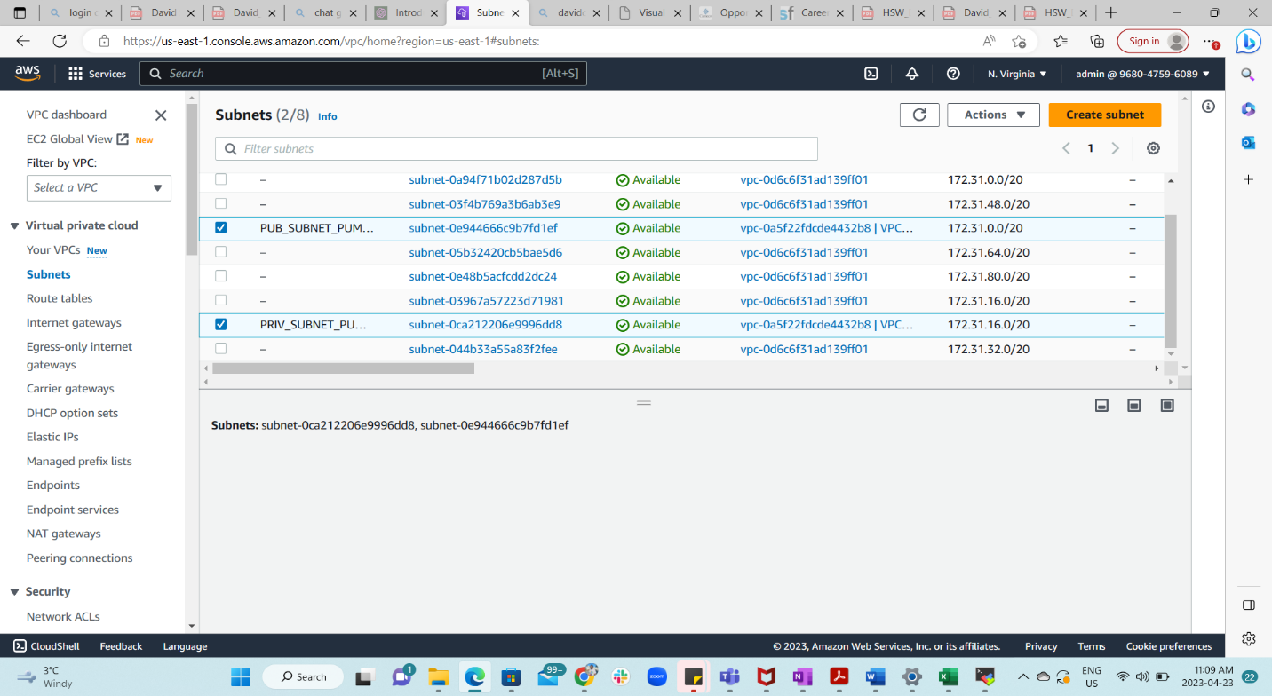

1. Create a custom route table for your private subnet called: Private_Route

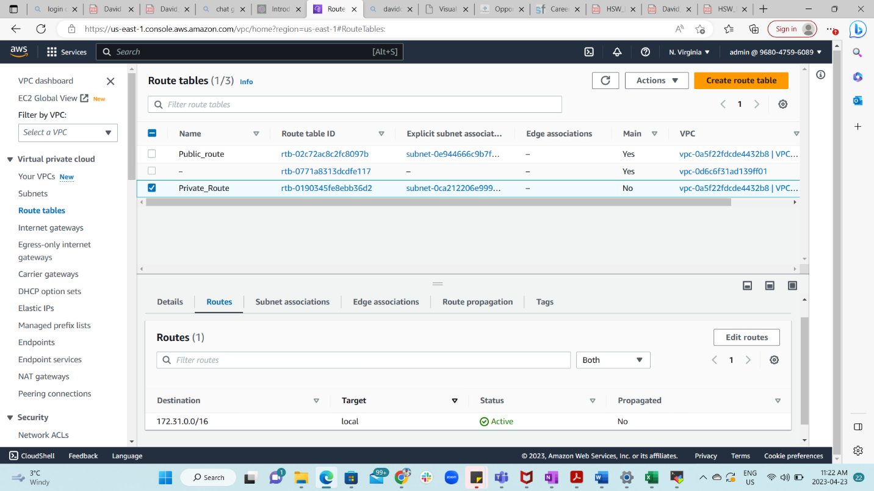

1. Create a custom route table for your public subnet called: Public_Route

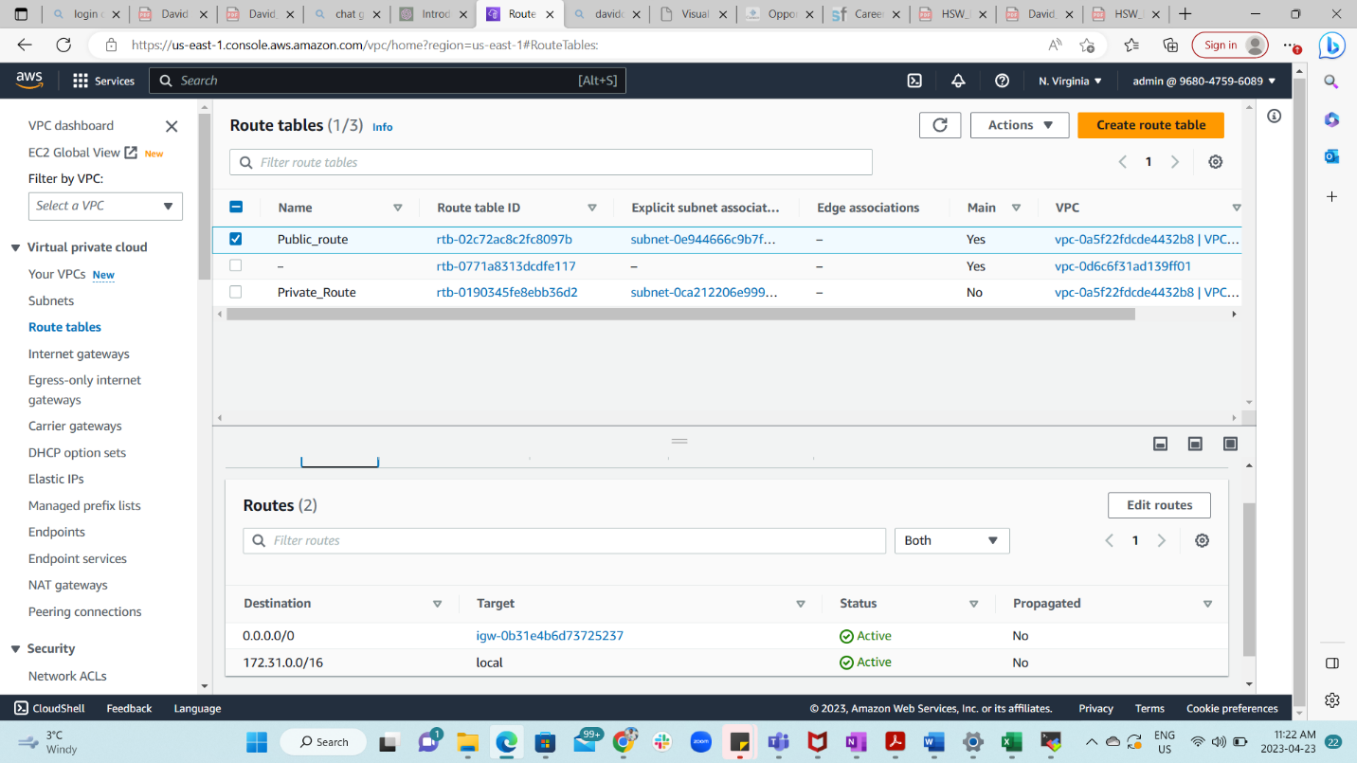

1. Create a security group called Web_Only_SG that only allows HTTP and HTTPS traffic from everybody. SG Web_Only_SG should also access to RDP traffic from 100.0.2.5/24 ONLY.

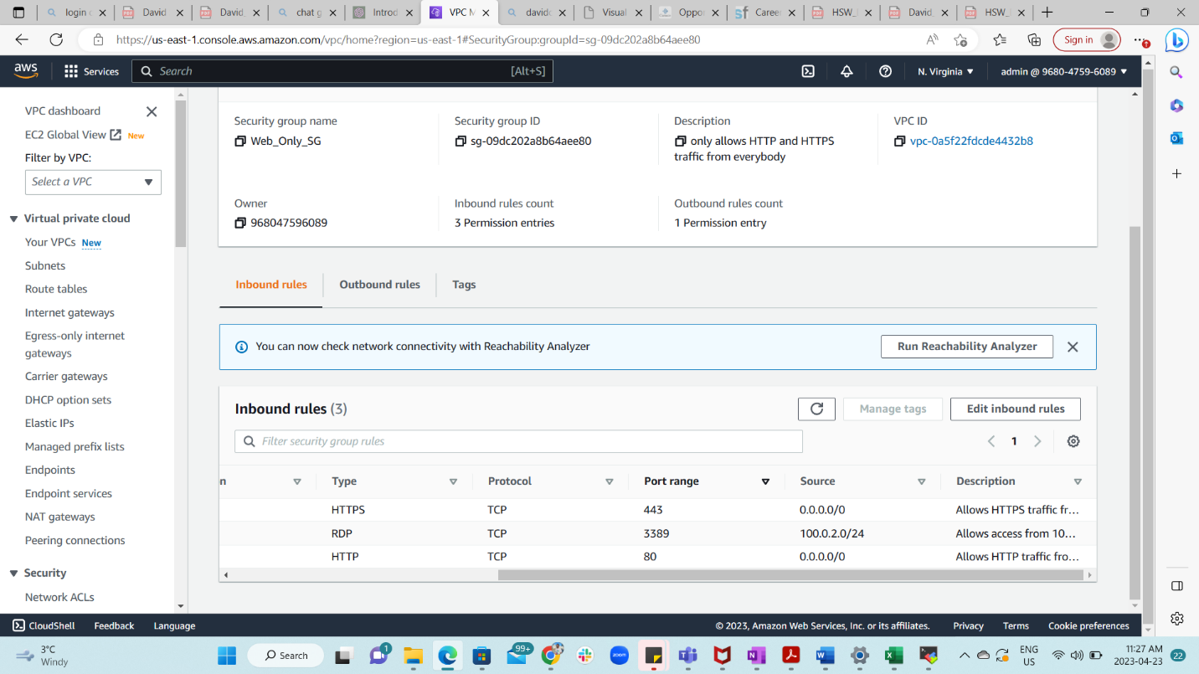

1. Create a NACL that allows ALL Traffic to everyone but prevent 19.2.5.2/24 from accessing SSH

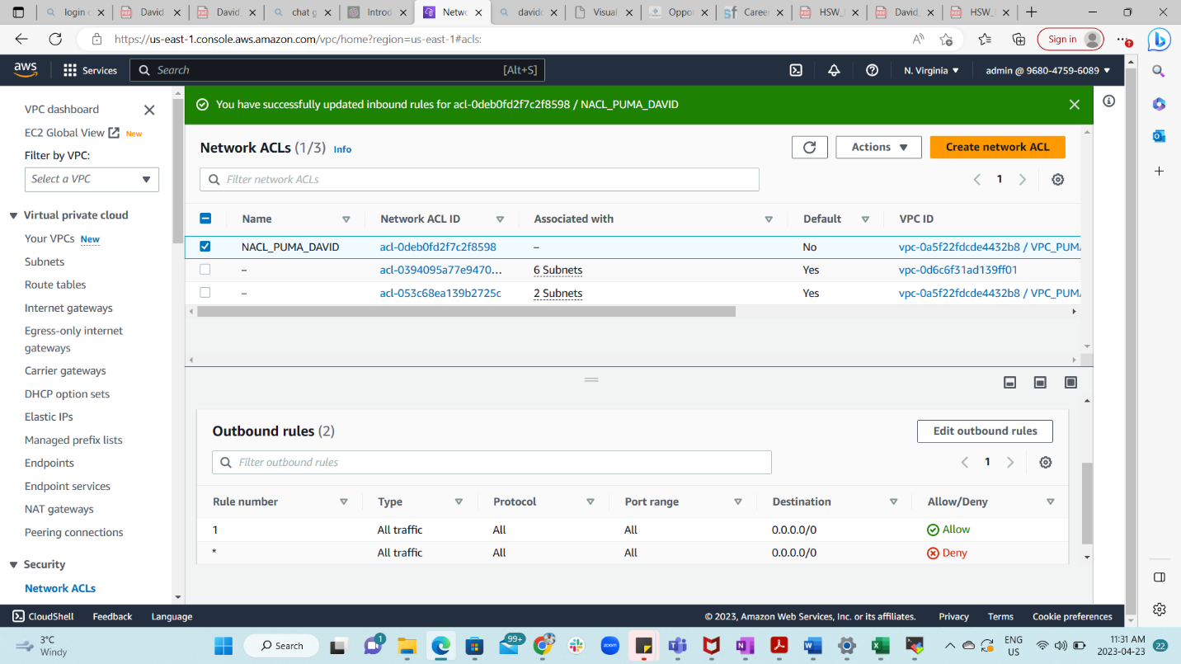

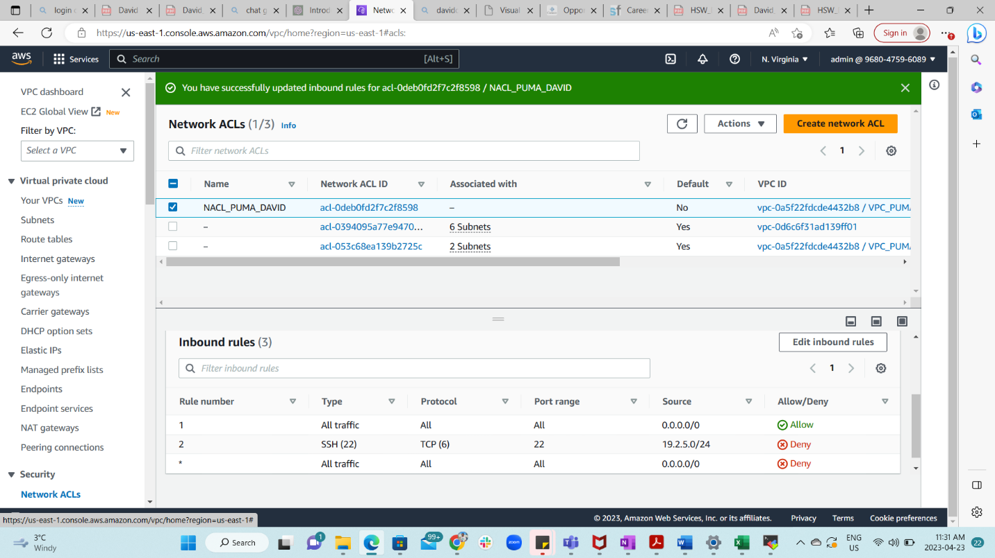

**Part 1 – Foundation:**

1. Build a VPC with a Private & Public Subnets.

1. Create a custom route table for your private subnet called: Private_Route

1. Create a custom route table for your public subnet called: Public_Route

**SG & NACL:**

1. Create a security group called Public_SG that only allows HTTP and HTTPS traffic from everybody. Your SG Public_SG should also allow ALL traffic from the peered account

1. Create a NACL that allows ALL Traffic from everyone A screenshot of a computer

   Description automatically generated

**Part 3 – VPC Peering :**

Work with someone in your team to peer your VPC with their

**Part 4 – Testing (Optional)**:  
Launch an EC2 in your account and make sure you can PING the EC2 in the other account (peered account)  using their private IP.

